**LAB 8**

**1 Write a program to store characters 'A' to 'Z' in the file .**

**Display the contents of file.**

#include<iostream>

#include<fstream>

using namespace std;

int main()

{

fstream file;

file.open("Alpha.txt",ios::out);

for(int i=65;i<=90;i++)

{

file<<char(i)<<" ";

}

file.close();

cout<<"Data inserted successfully!!!";

}

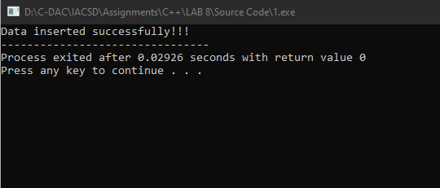

**2. Create class cEmployee with data members as empno,name and salary.**

**Accept values from user. Store it in file.**

**Display the contents from file.**

**Program should be able to store information of multiple employees.**

#include<iostream>

#include<fstream>

#include<vector>

using namespace std;

class EMPLOYEE

{

private:

string name;

int empno;

double salary;

public:

EMPLOYEE(string name,int empo,double salary)

{

this->name=name;

this->empno=empno;

this->salary=salary;

}

void display()

{ fstream f;

f.open("Employee1.txt",ios::app);

f<<"\nname - "<<name<<"\nempno - "<<empno<<"\nsalary - "<<salary;

// cout<<"\nname - "<<name<<"\nempno - "<<empno<<"\nsalary - "<<salary<<endl;

f.close();

}

};

int main()

{

vector<EMPLOYEE>em;

string name;

double salary;

int ch,empno;

cout<<"1. Enter Details 2.Read File 3.EXIT "<<endl;

do

{

cout<<"\nEnter Choice - ";

cin>>ch;

switch(ch)

{

case 1:

{

cout<<"\nEnter Name - ";

cin>>name;

cout<<"Enter Employee number - ";

cin>>empno;

cout<<"Enter Salary - ";

cin>>salary;

EMPLOYEE *emp=new EMPLOYEE(name,empno,salary);

em.push_back(*emp);

for(int i=0;i<em.size();i++)

{

em[i].display();

}

cout<<"\nData Stored Successfully!!!"<<endl;

break;

}

case 2:

{ string out;

fstream fout("Employee1.txt");

//fout.open("Employee.txt",ios::in);

while(getline(fout,out)){

cout<<out<<endl;

}

fout.close();

}

case 3:

break;

default:

cout<"Invalid Input!!!";

}

}while(ch!=3);

}

**3:Write a program to copy the contents of one file and write it into another file and print it.**

using namespace std;

int main()

{

fstream fin;

string message,med;

fin.open("fin.txt",ios::out);

cout<<"Enter Message - ";

cin>>message;

fin<<message;

cout<<"Data Stored Successfully!!!";

fin.close();

//char arr[6];

fstream fout;

fout.open("fin.txt",ios::in);

while(getline(fout,message))

{

cin>>med;

cout<<message;

}

cout<<"hello";

//fout.get(arr,5);

fout.close();

// cout<<arr[0]<<arr[1];

fstream fset;

fset.open("fout.txt",ios::out);

fset<<med;

fset.close();

}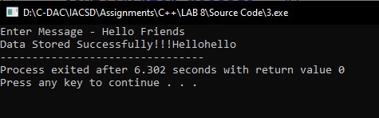

**4:Create a C++ program that does the following:**

**Initializes an empty vector of integers.**

**Asks the user to enter a series of integers and adds them to the vector until the user enters a specific sentinel value (e.g., -1).**

**Prints the elements of the vector.**

**Calculates and prints the sum and average of the values in the vector.**

#include<iostream>

#include<vector>

using namespace std;

int main()

{ int count=0,n;

double sum=0;

vector<int>data;

cout<<"-------------Enter the numbers-----------"<<endl;

while(n>=0)

{ count++;

cout<<"Enter number "<<count<<" - ";

cin>>n;

if(n<0)

{

break;

}

data.push_back(n);

}

for(int i=0;i<data.size();i++)

{

sum=sum+data[i];

}

cout<<"\nSum - "<<sum<<"\nAverage - "<<sum/data.size();

}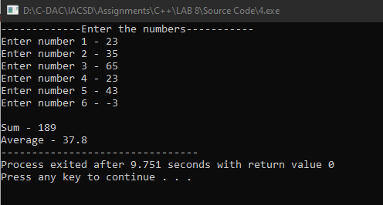

**5:Defines a Student class with attributes like name, age, and grade.**

**Initializes a vector of Student objects.**

**Allows the user to add new students to the vector with their name, age, and grade.**

**Prints the list of students.**

#include<iostream>

using namespace std;

#include<vector>

class STUDENT

{

private:

string name;

int age;

char grade;

public:

STUDENT(string name,int age,char grade)

{

this->age=age;

this->name=name;

this->grade=grade;

}

void show_details()

{

cout<<"\nName - "<<name<<"\nAge - "<<age<<"\nGrade - "<<grade<<endl;

}

};

int main()

{

vector<STUDENT>stud;

int age,ch,count=0;

string name;

char grade;

STUDENT s(name,age,grade);

cout<<"\n1. Enter Details 2.Display details 3. EXIT"<<endl;

do

{

cout<<"\nEnter choice - ";

cin>>ch;

switch(ch)

{

case 1:

{ count++;

cout<<"\nEnter the details of student "<<count<<" : ";

cout<<"\nEnter name - ";

cin>>name;

cout<<"Enter Age - ";

cin>>age;

cout<<"Enter Grade - ";

cin>>grade;

STUDENT s(name,age,grade);

stud.push_back(s);

cout<<"\nData Stored Successfully!!!"<<endl;

break;

}

case 2:

{ count =0;

for(int i=0;i<stud.size();i++)

{

count++;

cout<<"\nStudent "<<count<<":";

stud[i].show_details();

}

}

case 3:

break;

default:

cout<<"Invalid Input!!!";

}

}while(ch!=3);

}

